EX.NO:06 REG.NO:210701319

DATE:

**PUBLIC CLOUD CREATING AN INSTANCE IN MICROSOFT AZURE**

**AIM:**

Develop a simple application to understand the concept of PAAS using Microsoft Azure.

**PROCEDURE:**

1. Sign in to the Azure portal

2. Select Azure SQL on the left menu of the Azure portal.

3. Select +Add to open the Select SQL deployment option page.

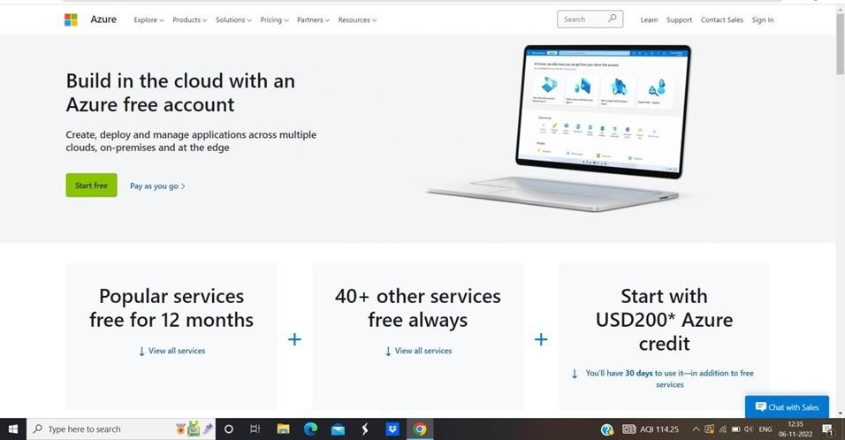4. Select Create.

**OUTPUT:**

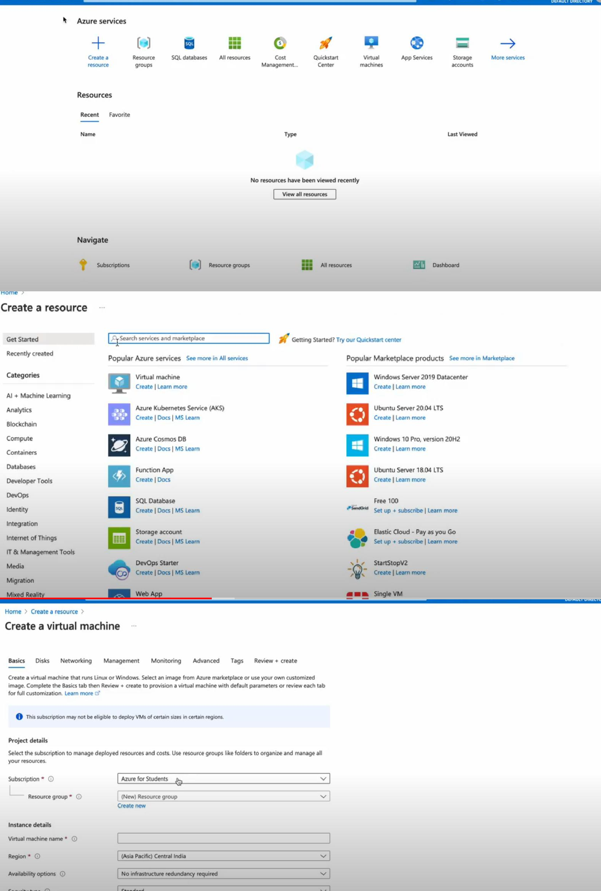

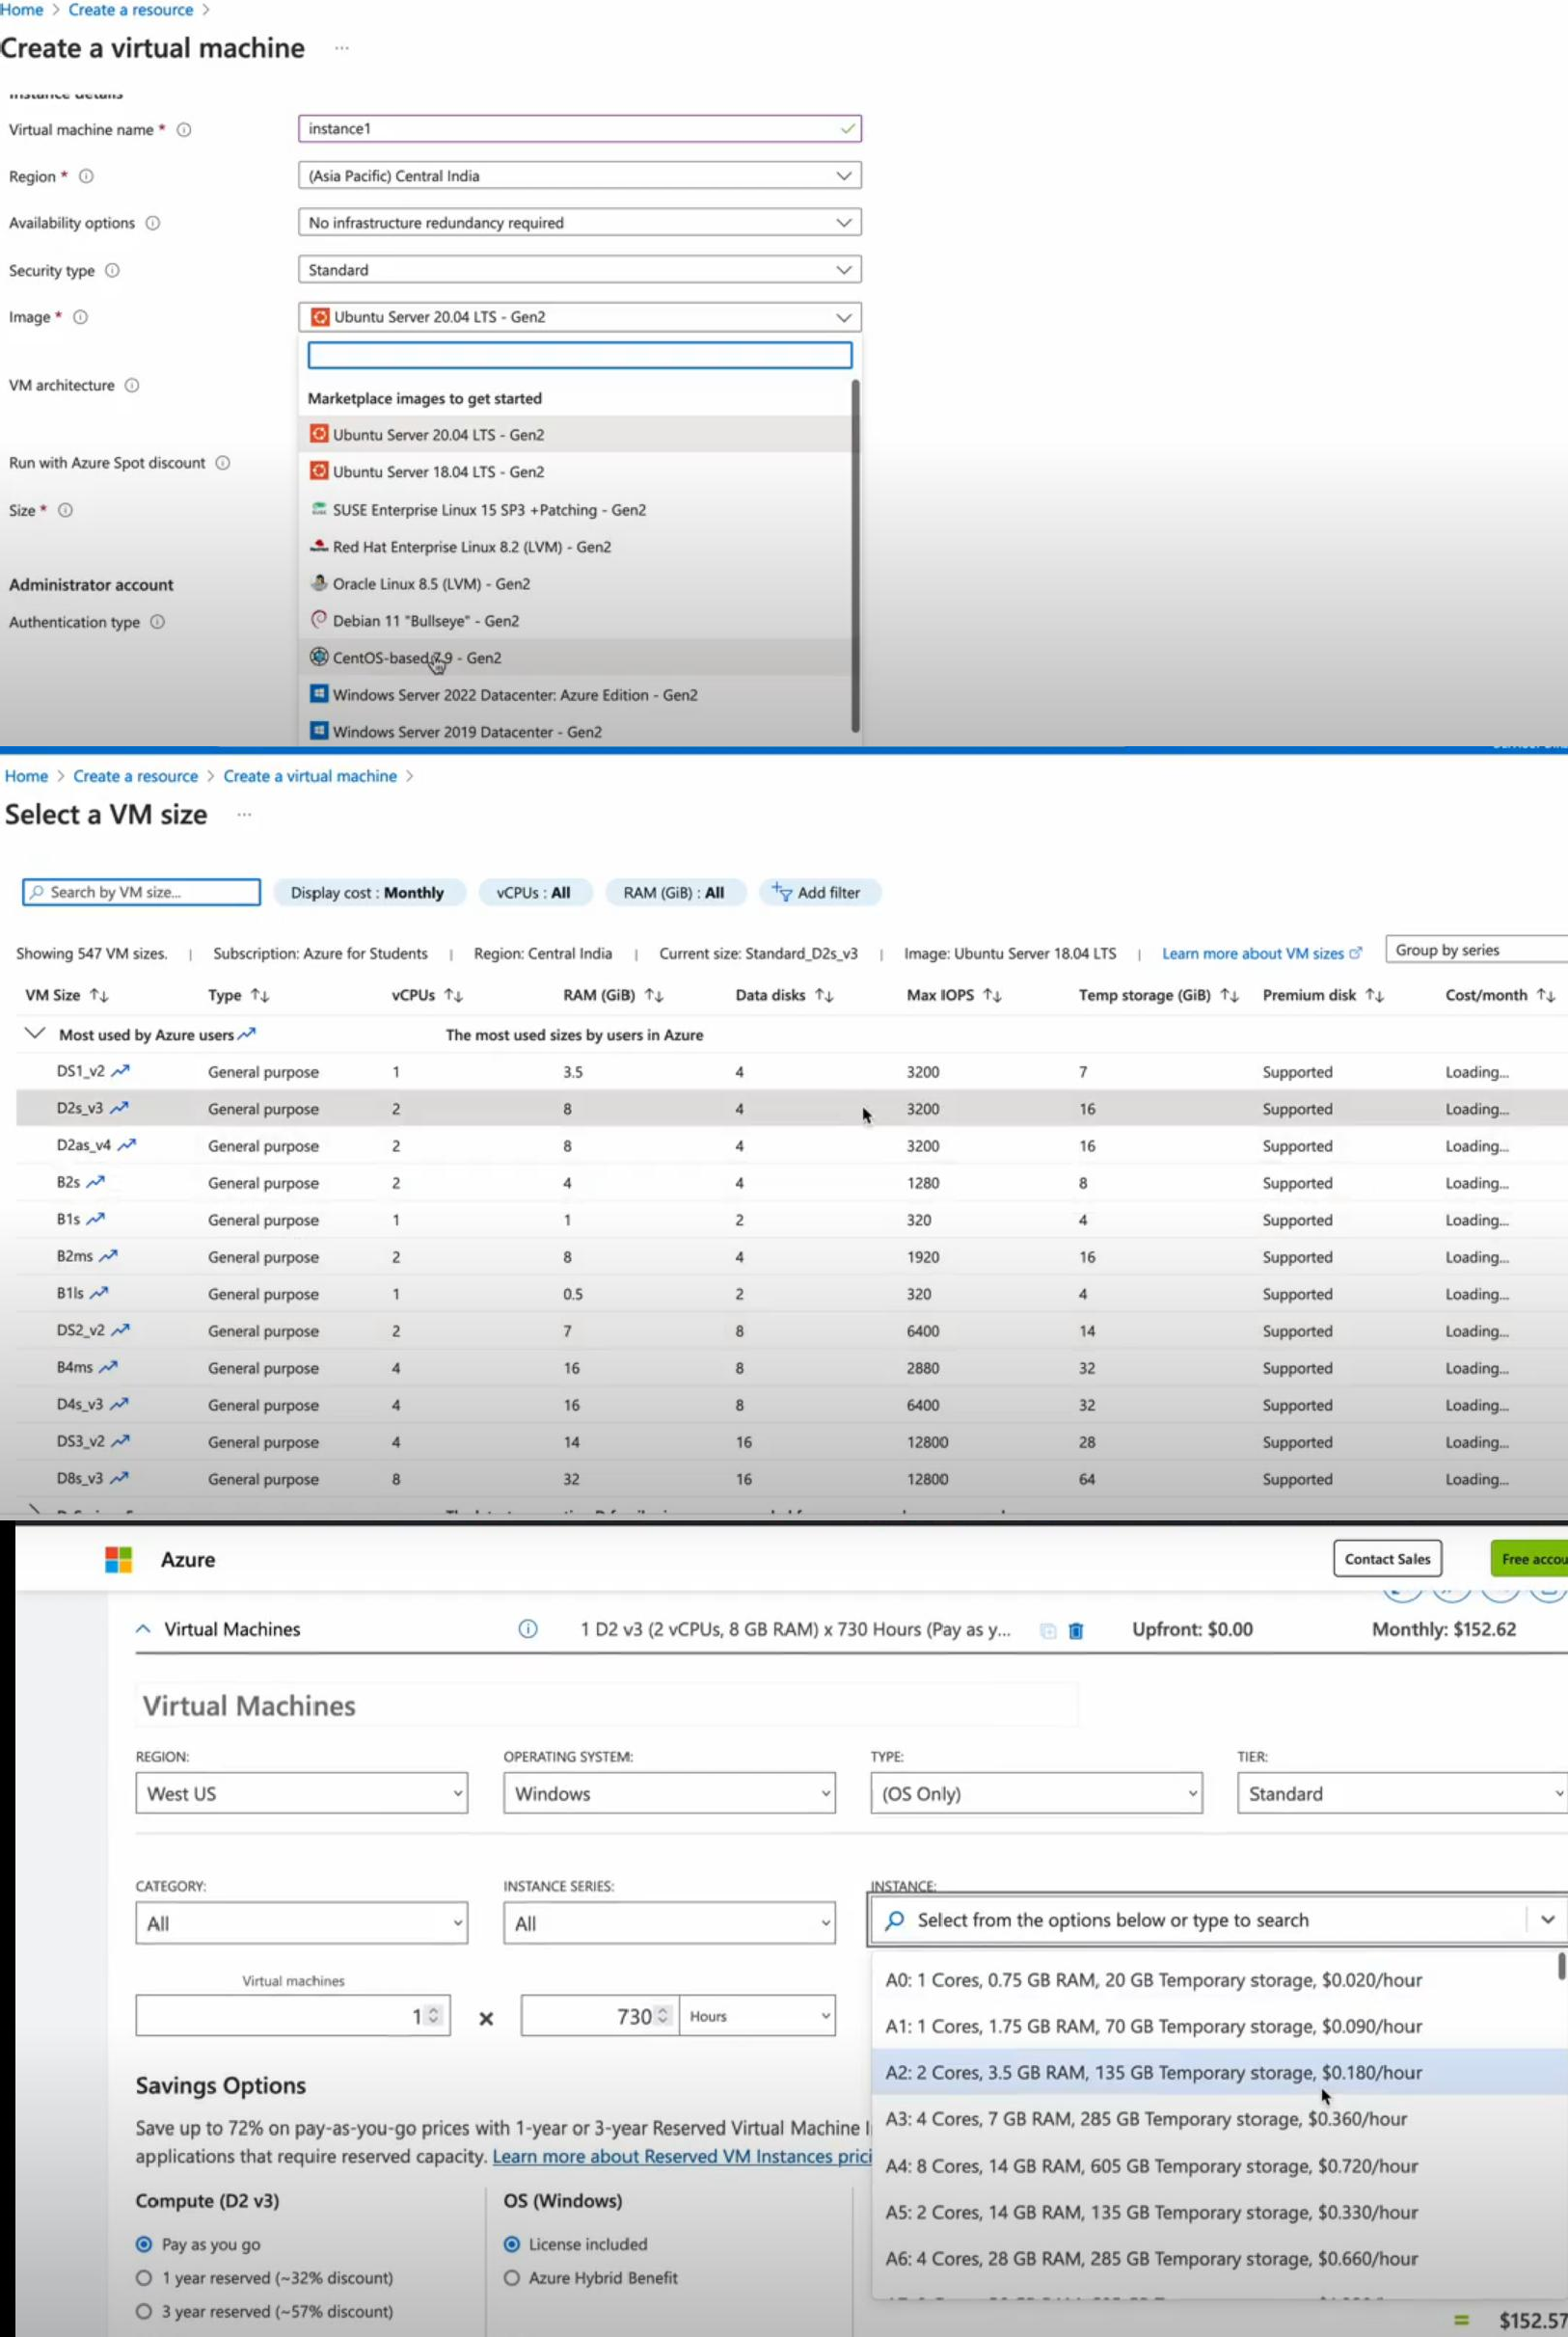

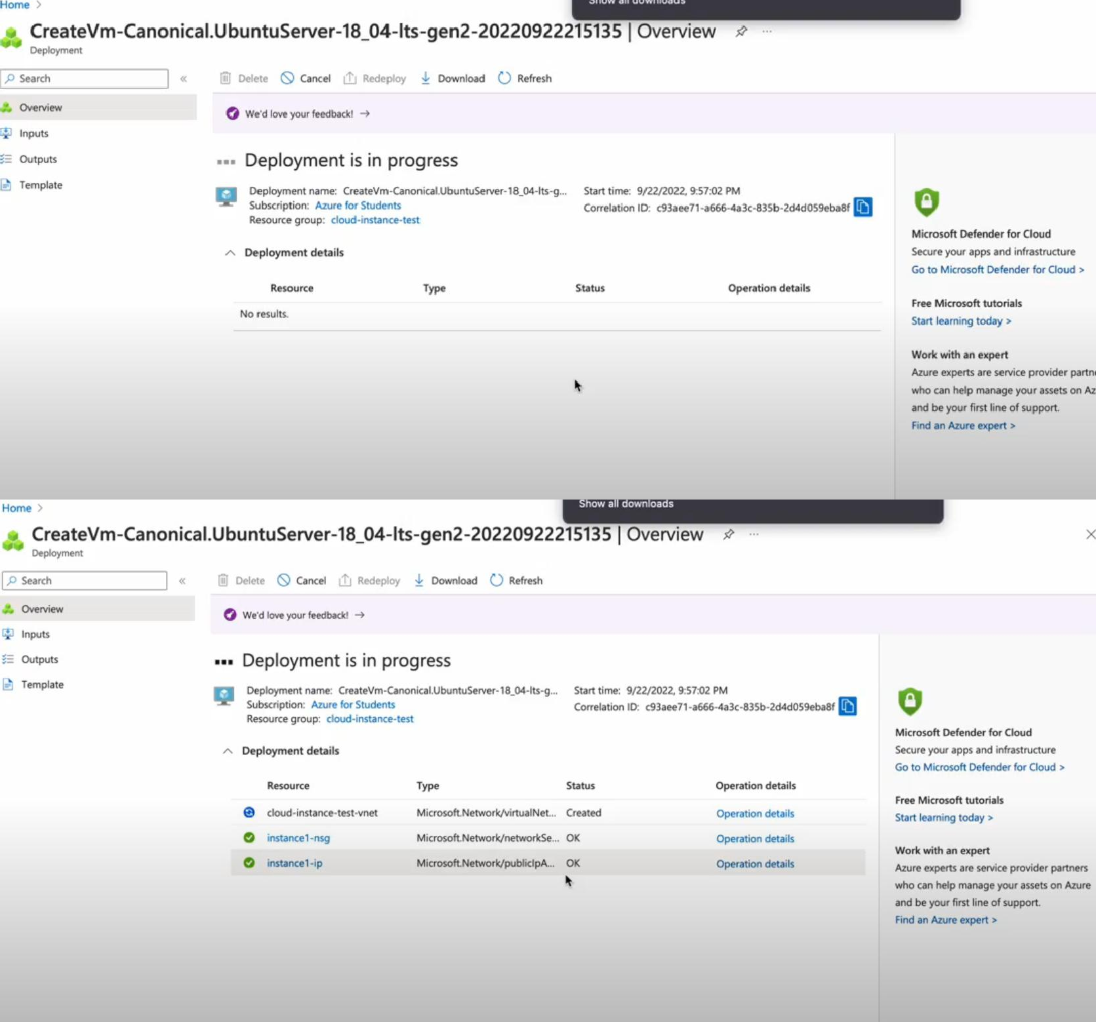

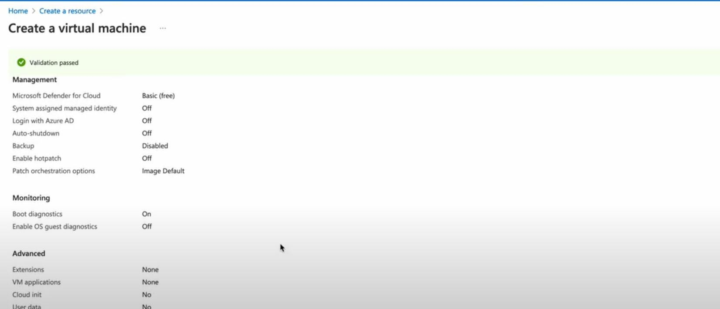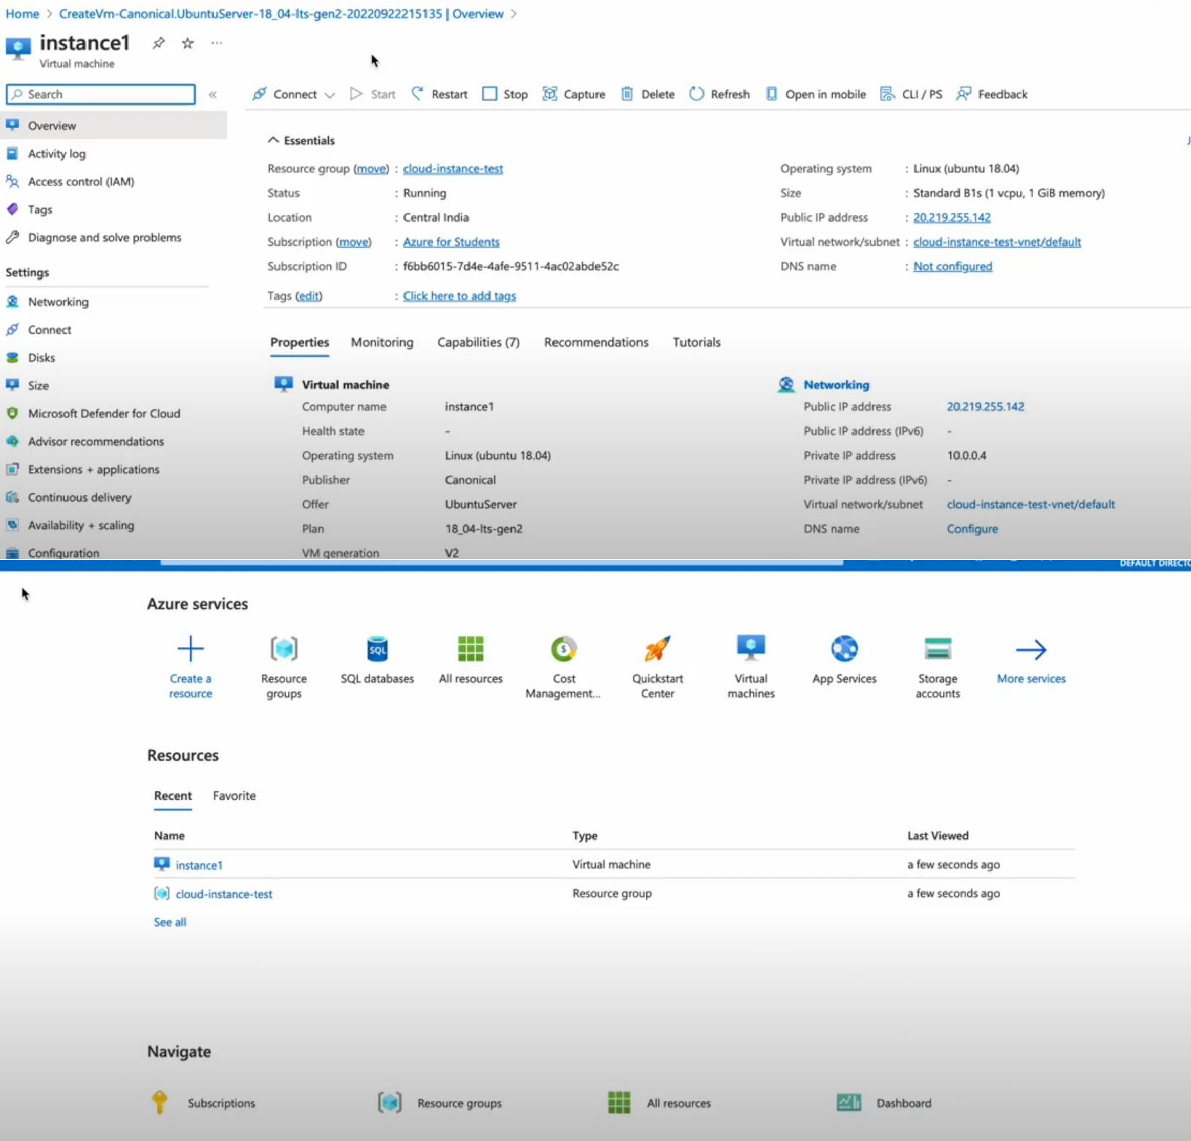

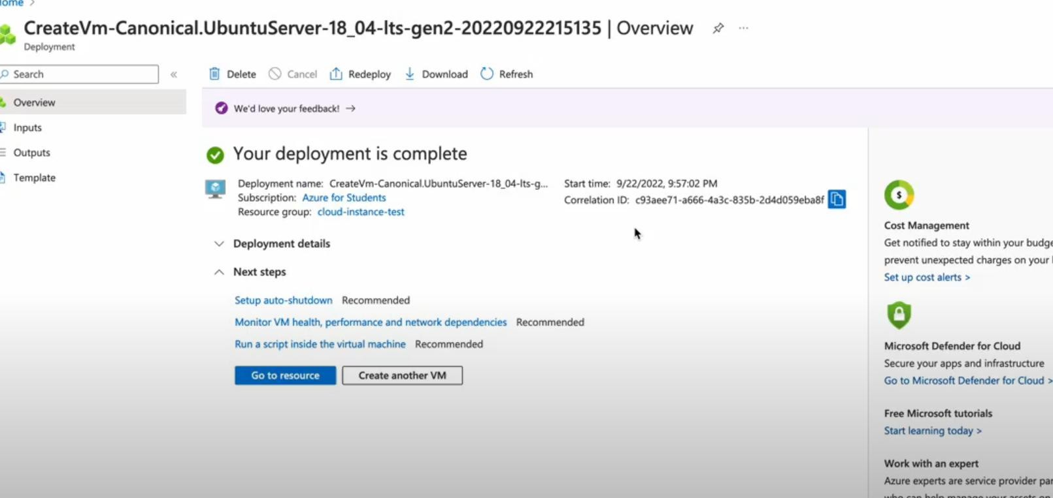

**RESULT:**

Thus an application instance has been created in Microsoft Azure successfully.